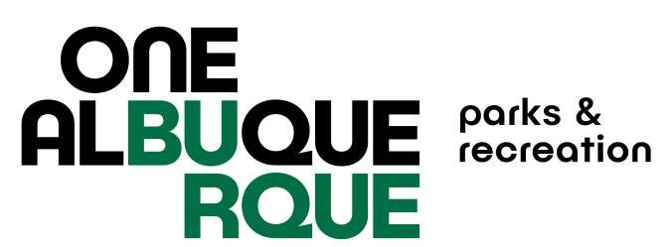
City of Albuquerque Parks and Recreation
2025 SUMMER Softball
Registration Check List
Each item listed below must be completed in order for your team to participate: Teams who do not turn in the required paperwork will not receive a schedule and will have to forfeit games. Paperwork must be turned in to the office – no email, fax or other electronic paperwork accepted.
REGISTRATION FEES ARE NON-REFUNDABLE ONCE REGISTRATION CLOSES.
Complete and turn in TEAM REGISTRATION FORM to the Jerry Cline Recreation and Tennis Center by March 21, 2025, 5:30pm. Spots fill up fast. You will be put on a wait list if division and night is full.
Pay the $990.00 TEAM FEE at the Jerry Cline Tennis Center at the time you turn in your team registration form. Forms of payment accepted are: cash, check, credit card.
Pay the $50.00 USSSA sanction fee at http://www.rctipif.org. Please go through this website ONLY as all other website registrations are not valid for the City of Albuquerque leagues. This fee is required once per year and covers spring, summer, fall seasons.
Turn in original completed team roster with all signatures and ID numbers filled
in, USSSA waiver of liability form, Code of Conduct Form signed by individual
participants, and proof of USSSA Sanction Fee for 2025 by April 3, 2025 to the Jerry
Cline Recreation and Tennis Center. All players must sign a new USSSA waiver and
CABQ Code of Conduct each season.

Managers must attend the rules and conduct meeting at Jerry Cline on
March 31st or April 2nd 2025.

